

ETHICAL HACKING AND COUNTER MEASURES
MR MICHAEL
BSCCS/2024/56022
THIORA EMMANUEL
BIT4139

TABLE OF CONTENTS

WEEK 1 2
NMAP INSTALLATION 2
BASIC SCAN 3
WEEK 2 5
RUNNING SERVICES AND OS VERSION 5
IP ADRESSES USING SHODAN 5
WEEK 3 6
EMAIL PATTERNS USING MALTEGO 6
DOMAIN REGISTRAR 7
DOMAINS AND SUBDOMAINS 7

WEEK 1

NMAP INSTALLATION
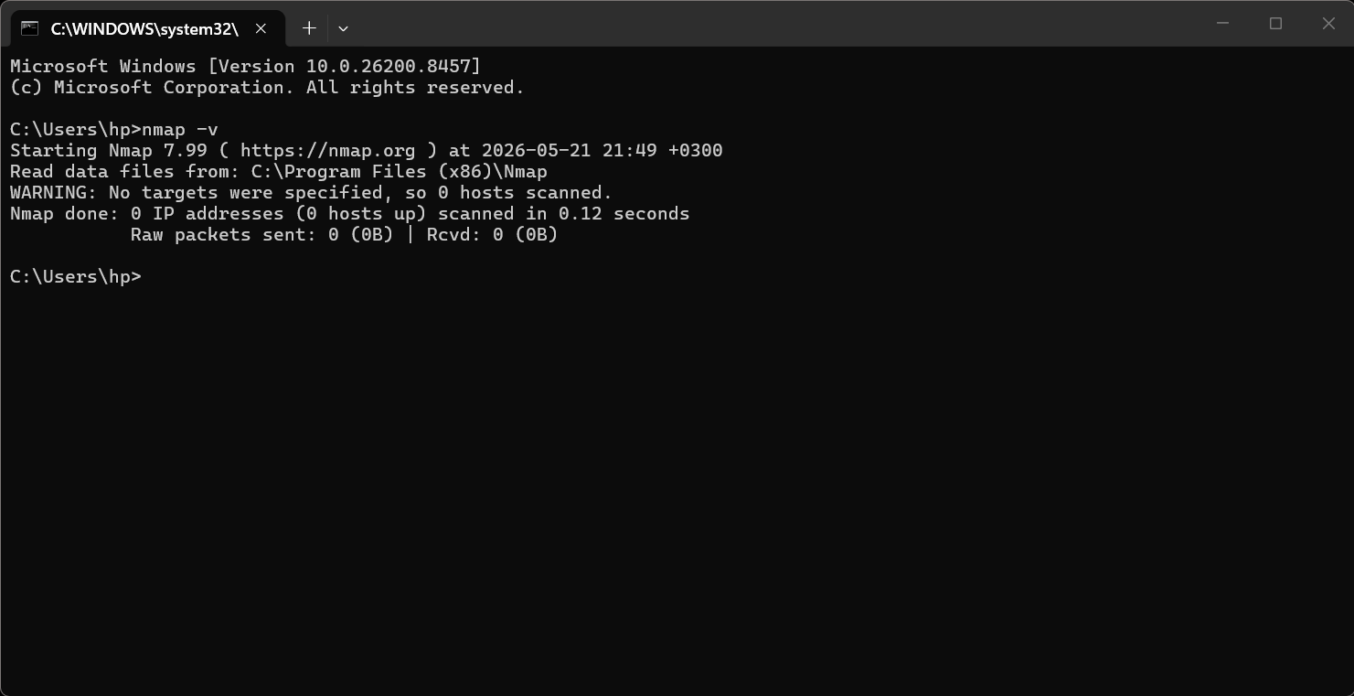

BASIC SCAN
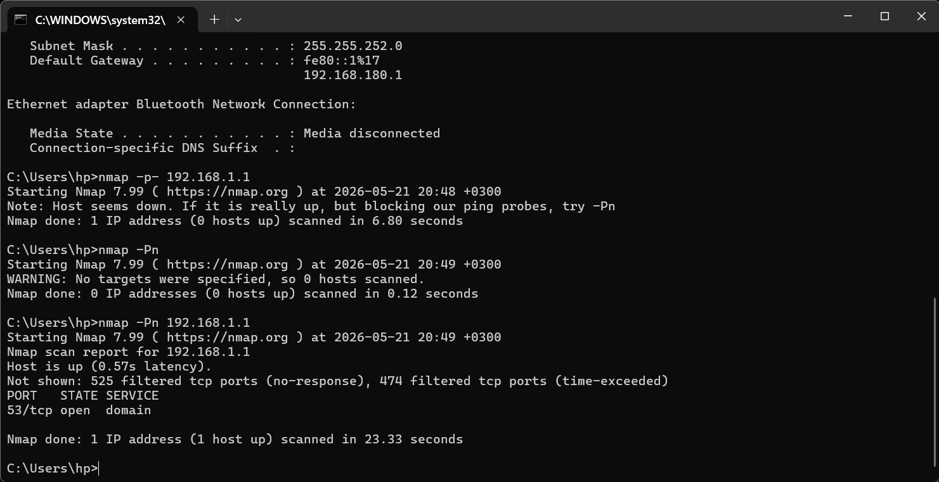
PORT SCANNING ON DEVICE
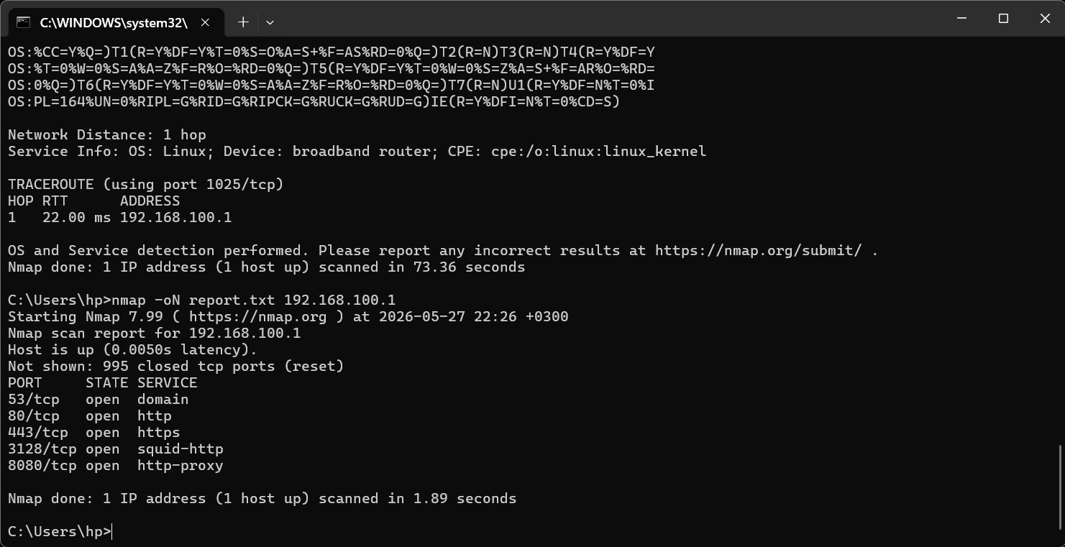

Reflection :
Using Nmap, port scanning and vulnerability checks were performed on selected IP addresses. The tool helped identify open ports, running services, and possible security weaknesses. This exercise showed how Nmap is useful in ethical hacking and network security assessment.

WEEK 2

RUNNING SERVICES AND OS VERSION
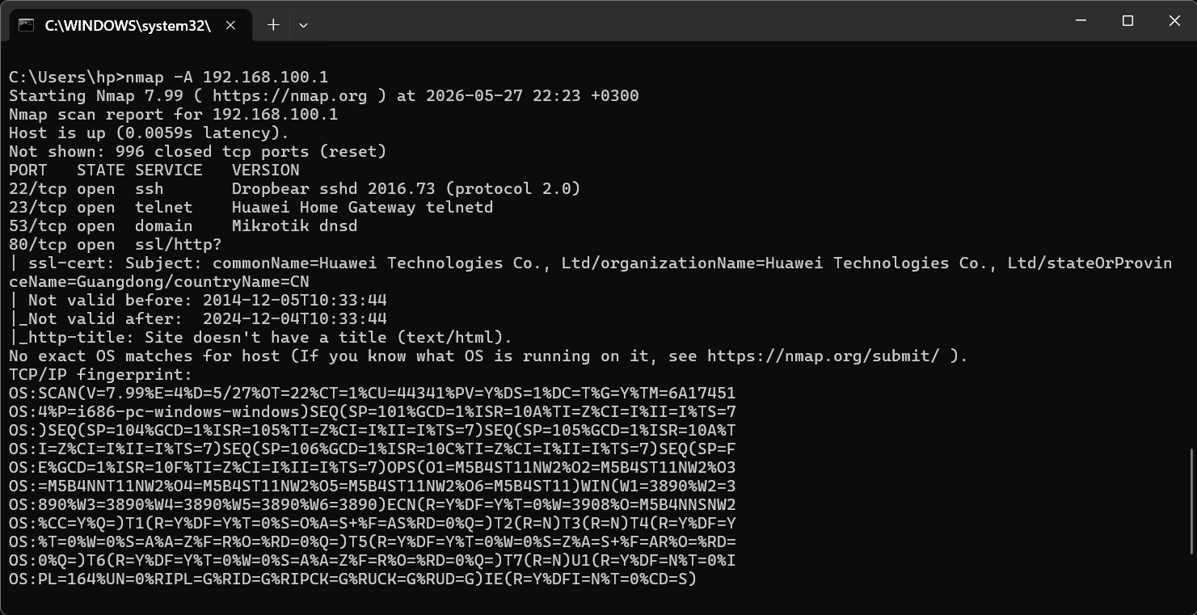

IP ADRESSES USING SHODAN
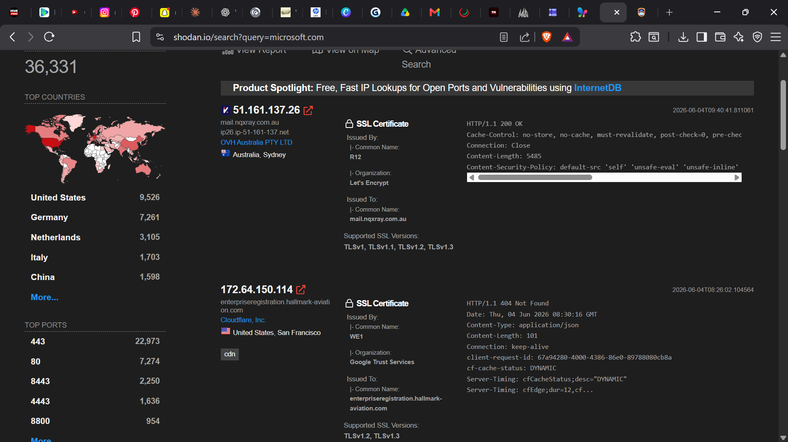

Shodan is a cybersecurity search engine that reveals internet-connected devices, exposing vulnerabilities, and misconfigurations. It demonstrates the importance of securing systems, patching software, and understanding digital exposure risks ethically responsibly.

WEEK 3

EMAIL PATTERNS USING MALTEGO
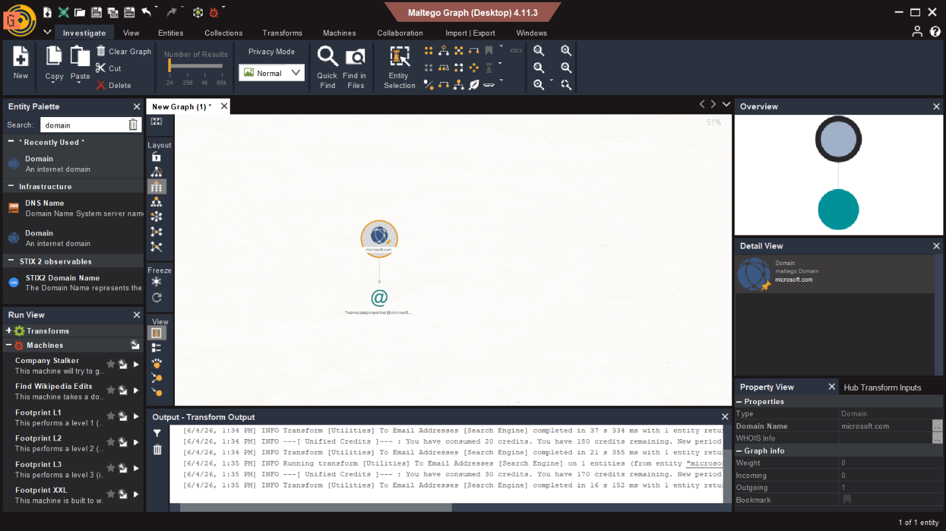

DOMAIN REGISTRAR
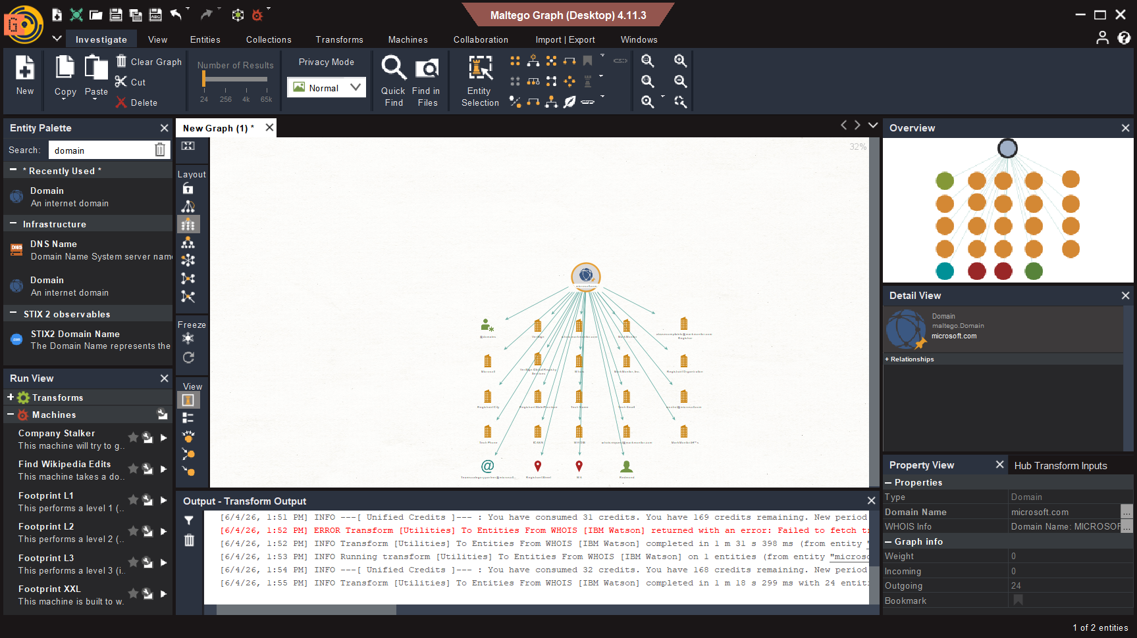

DOMAINS AND SUBDOMAINS
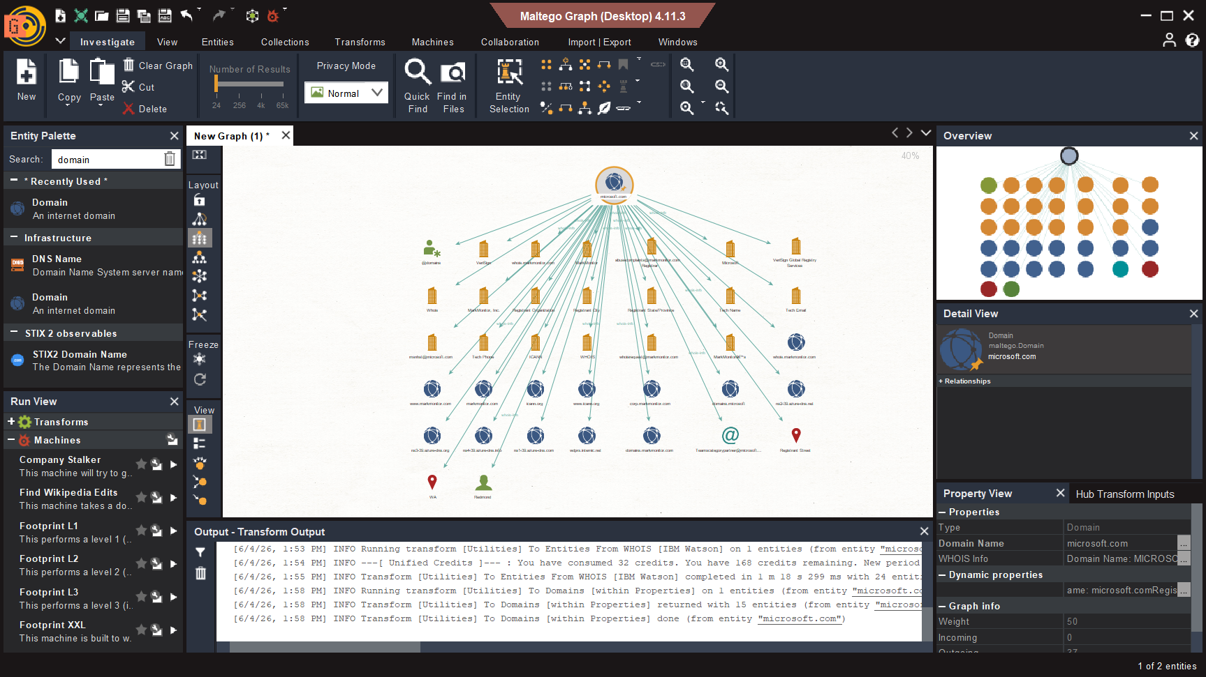

Reflection:
Maltego proved to be an effective OSINT and foot printing tool for discovering publicly available information related to microsoft.com. The tool assisted in identifying domains, email patterns, registrar information, and infrastructure assets.

